1. Start with Section 1, “Port Scanning with Netcat,” and capture a screenshot of the following:
   1. Step 6 output

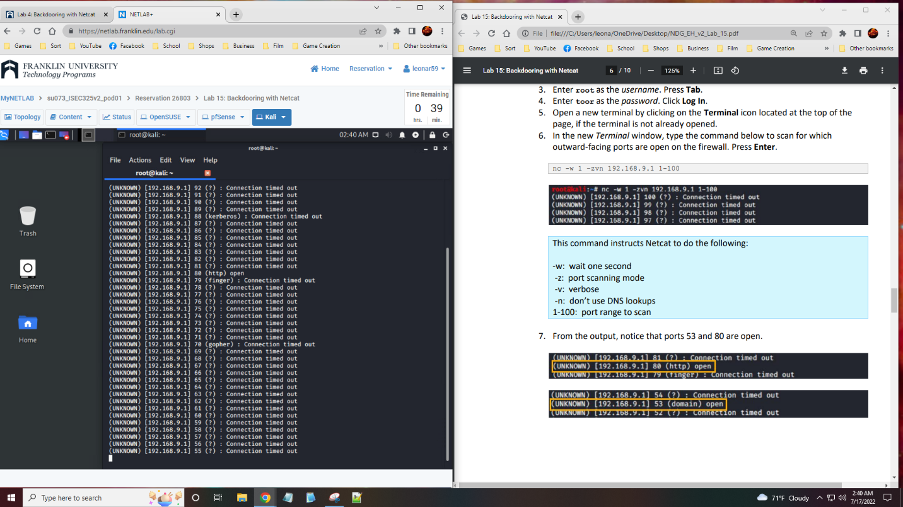

1. Continue with Section 2, “Establishing Connections with Netcat,” and capture a screenshot of the following:
   1. Step 11 display

1. Continue with Section 3, “Transferring Files with Netcat,” and capture a screenshot of the following:
   1. Step 10 file list

1. Summary and Reflection: In a few paragraphs, reflect on what you learned through this lab assignment. Was there anything surprising or unexpected? Was there anything worth investigating further?

In this lab we were able to find the ports of the computer, find an open one and connect to it using another computer. Then we were able to send and receive files. This lab was interesting with how we could use an open port and reach another person. The lab shows that with netcat, we can talk directly with the person and even get files. Most of the labs use netcat or wireshark so it is interesting with just how much these different commands and programs can do.